Introduction Page 3
- What is Courier Ship Manager?
- Benefits of Courier Ship Manager
- Get Started
Comfortable View Page 4
Left Navigation Menu Page 5
Create a shipment Page 8
Manage shipments Page 9
Support Section Page 11
Compact View
Left Navigation Menu Page 10
Create a shipment Page 11
Manage shipments Page 15
Support Section Page 16

- Automatic updates, so you get new features and services as soon as they’re released

Get started
1
2
3
OPEN AC
Create user ID
and password
If you don’t have an
account number yet, sign
up from our homepage.
“Sign up/Login” on the top
right
-
word.
Prepare shipping labels
anytime, anywhere over
the internet.
click “SHIP”.

Comfortable View & Compact View

Comfortable View |  | Compact View
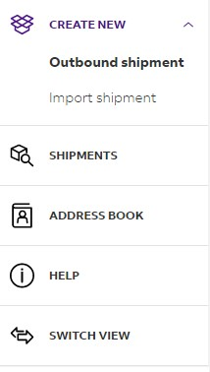  Follow the step-by-step screens – from air waybill creation to pickup reseveration |  | Find everything on a single screen – from air waybill creation to pickup reservation

Left Navigation Menu of Comfortable View
Comfortable View was especially designed for those shippers who would like a step-by-step approach. You’ll be walked through every step of the shipping process, to ensure you will not miss anything.
Use this section to create a new shipment. You can choose for an outbound shipment or an import shipment. Fill in the address details, package weight and dimensions, select a service for your shipment, and other required shipment information.
View a list of all the shipments you created. In this section, you can see the shipping status of your shipments and check for any updates. It also allows you to cancel shipments or reprint the labels.
View and edit your address book.
Click the Help section to find out more information about Courier Ship Manager and its features.
Select which Courier Ship Manager View you want to use. You can switch between the
Comfortable View and the Compact View.

Create a new shipment with Comfortable View
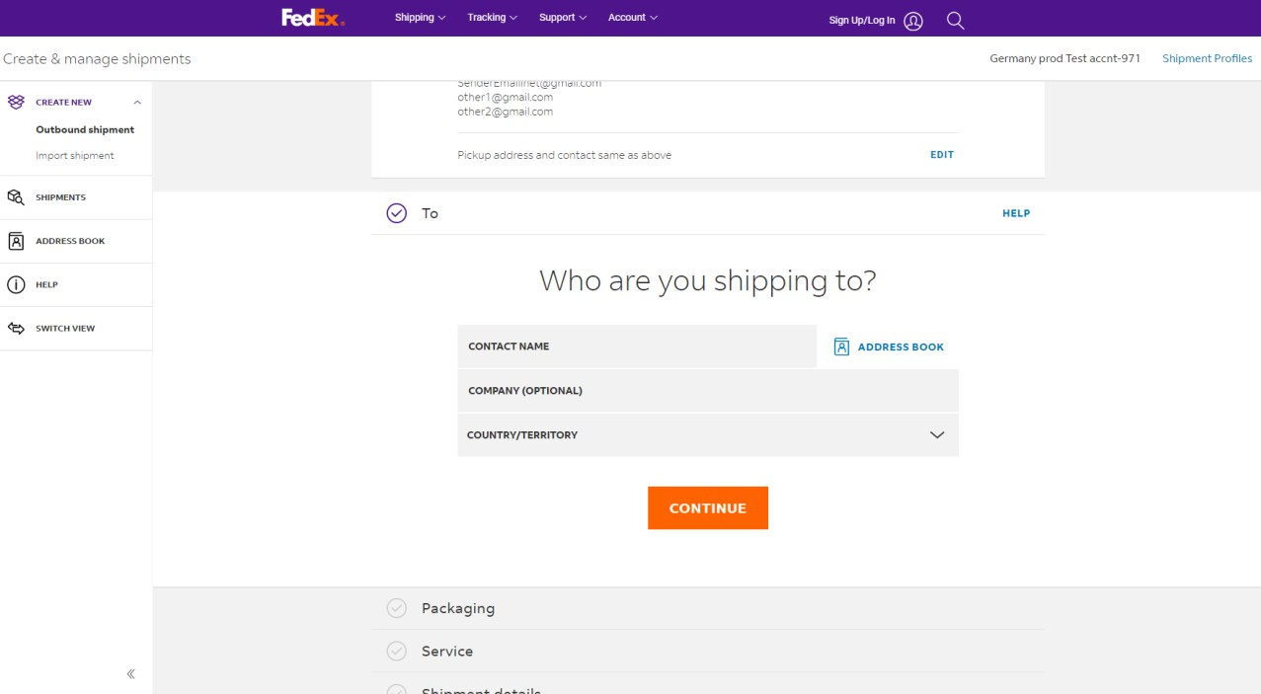1. Click "CREATE NEW" to open the shipment form.
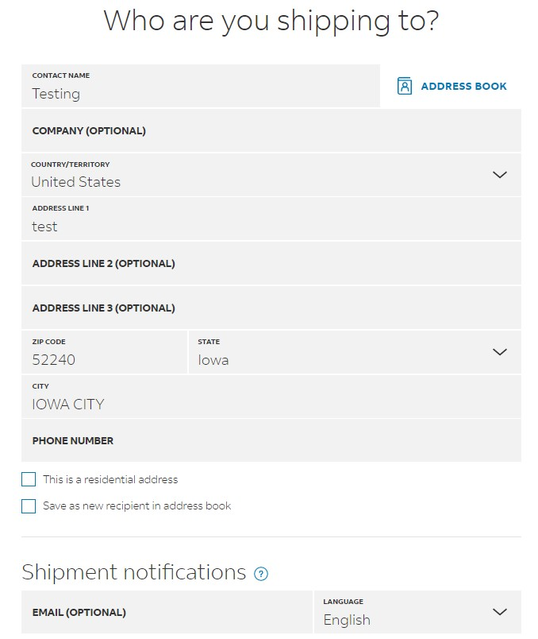
2. Provide the address details of the recipient.
You can select the address from your address book or add a new address. To save the new address in your address book, click the checkbox at the bottom.
You can also choose to receive Shipment Notifications.
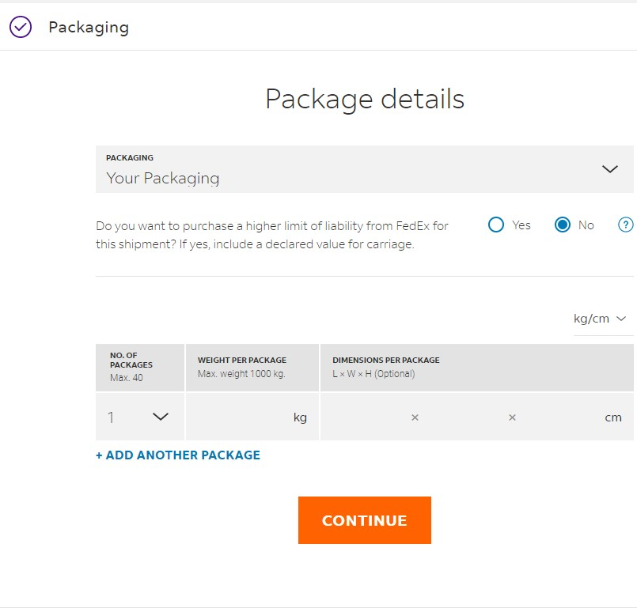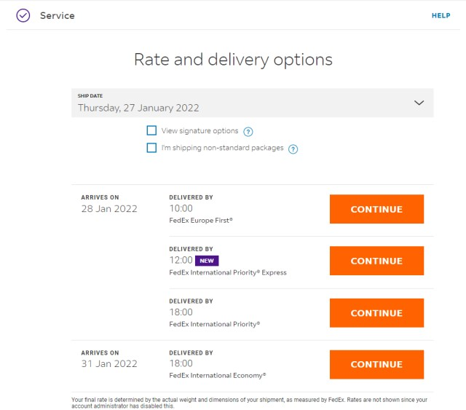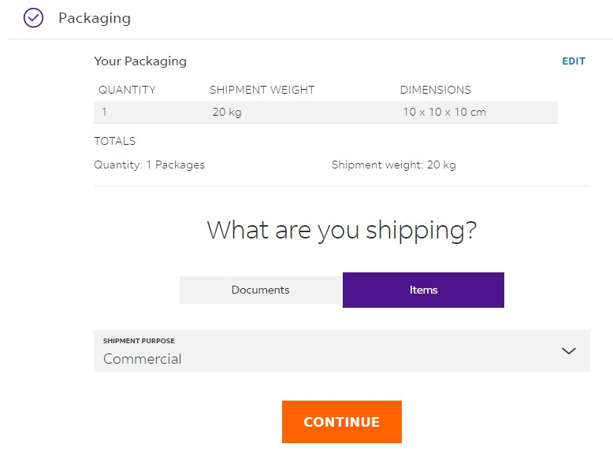
3
. Provide the package details.
Specify the package weight
and dimensions of your
shipment. This information is

correct cost for your
shipment. Once you have
filled in your dimensions, you
can select whether you ship a
document or items and
p
4
. Select a service for your shipping.
Choose a service for shipping. The service
availability depends on the origin and destination of
the shipment. The rates shown are linked to your
account setup.
Shipment purpose only
needs to be filled in if this is a
customs
-
controlled
shipment. For shipments that
are not customs controlled,
the goods description is
enough.
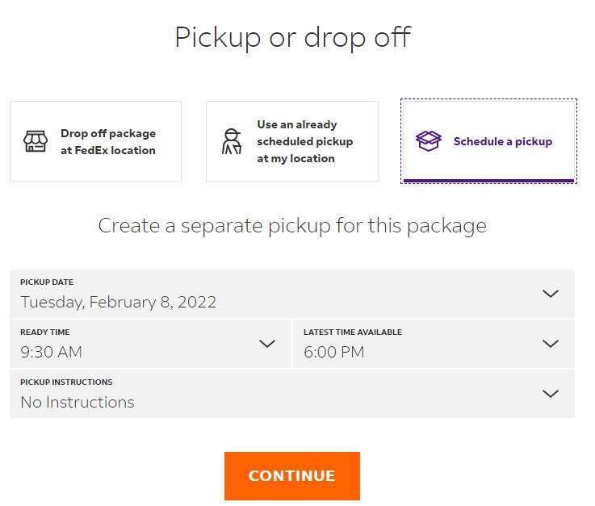
- Select the pickup time and date.Here you can select the pickup time and date. You can use an existing pickup, or create a new time and date. Depending on your location, you can also choose to drop off your shipment at a location.
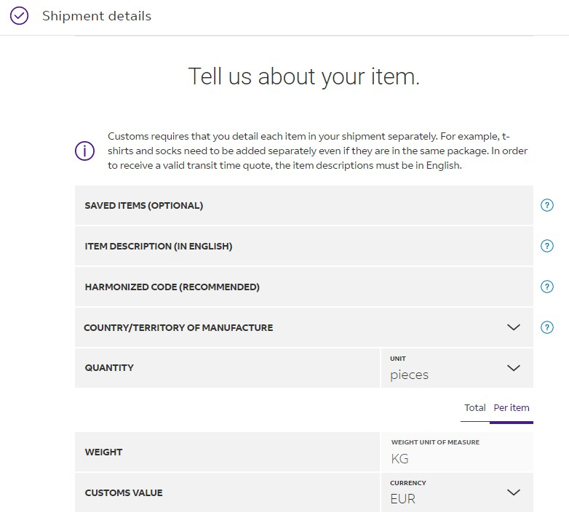
- Additional item information*If you are sending a customs-controlled shipment, we need to know additional information about your shipment, which you can fill in here.
*Only applies to customs-controlled shipments
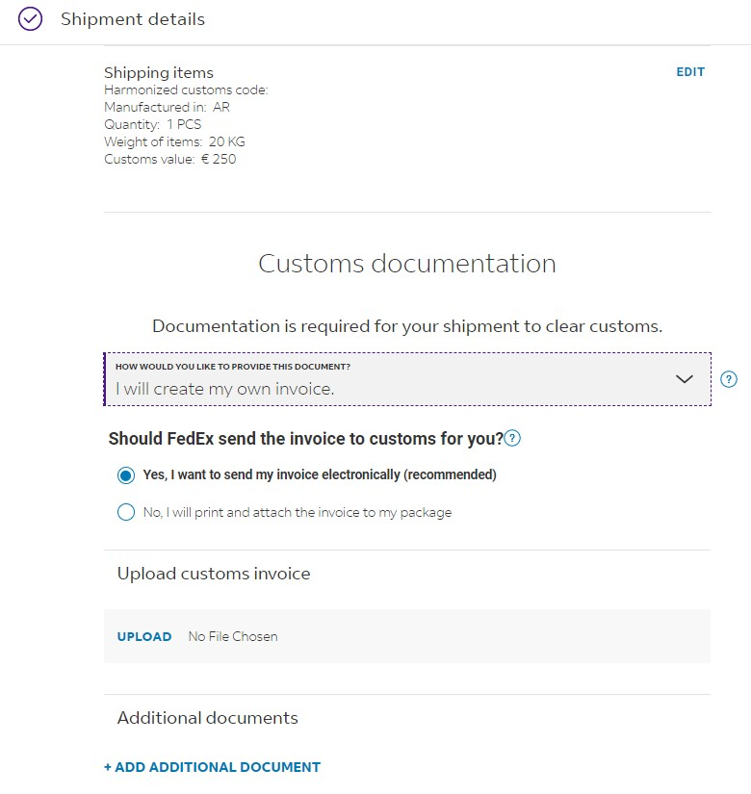
- Customs Documentation*If you are sending a customs-controlled shipment, you can upload your commercial invoice here. If you do not have a commercial invoice, can help you with creating one.
*Only applies to customs-controlled shipments
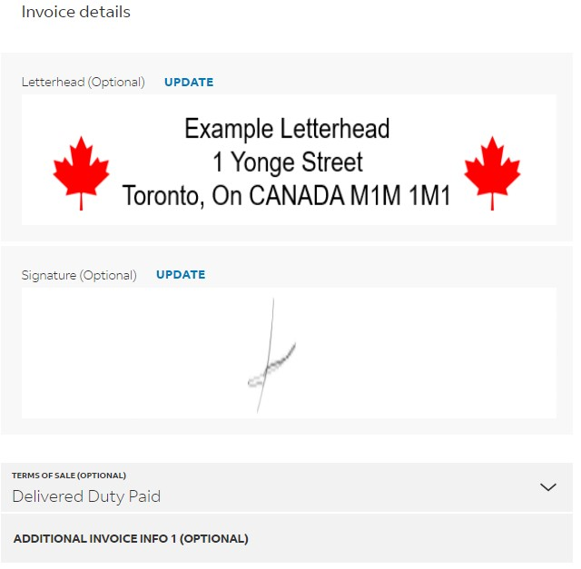
- Creating an invoice*If you want FedEx to assist you with creating a commercial invoice, you can fill in the details here.
*Only applies to customs-controlled shipments
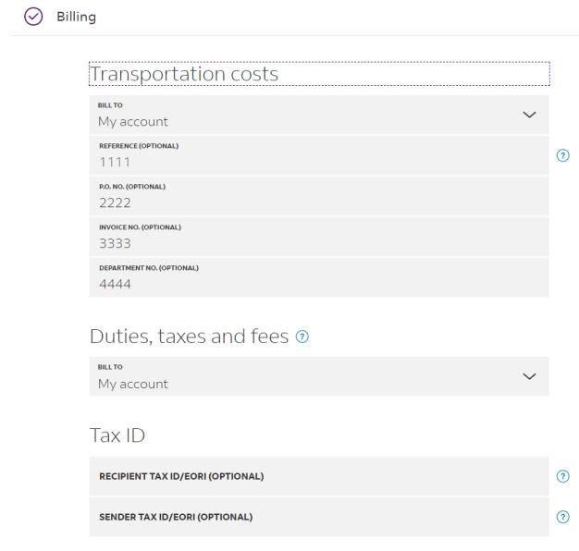
- Specify the billing information.
You can also select who you would like to bill for duties, taxes and fees (when applicable.) Note that if the requested party does not pay we will charge these costs to the shipper.
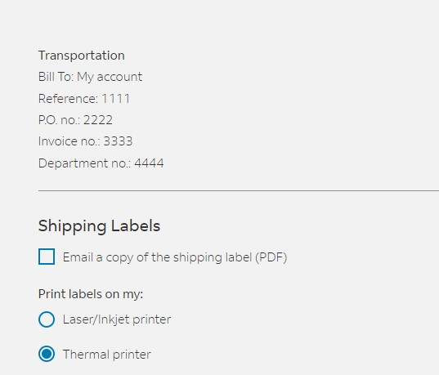
- Printing
Once you have filled in the billing information, you can choose how to print the labels.
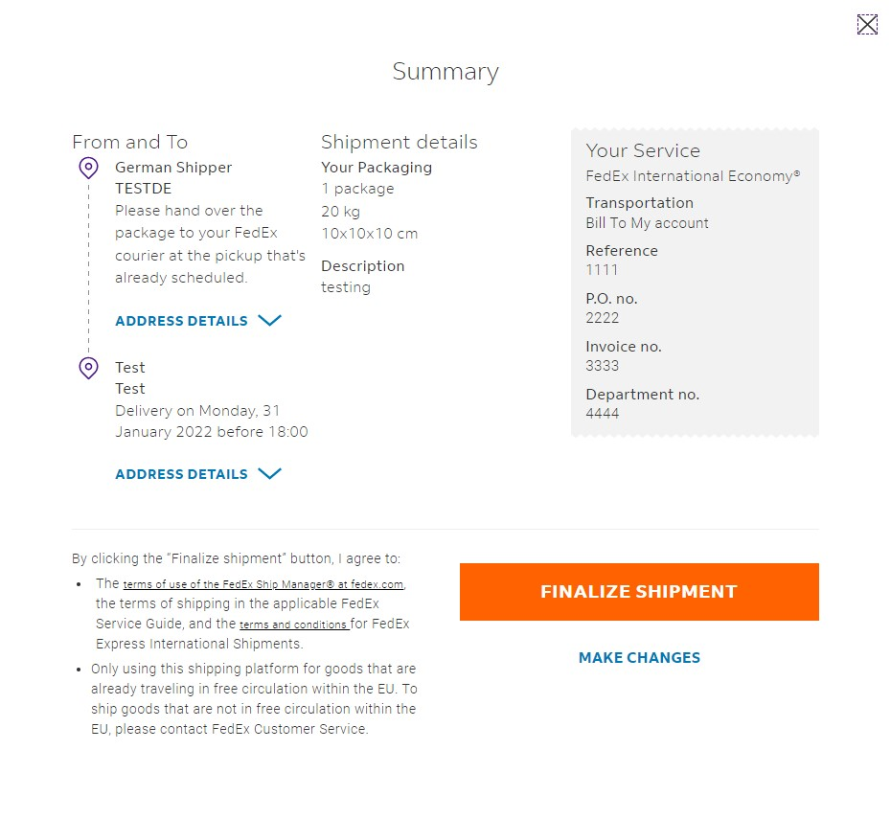
- Summary
Lastly you will see a summary of your shipment. You can make any changes if necessary. If the shipment is exactly how you like it, you can agree to the terms and conditions and finalize it.

Manage shipments Comfortable View
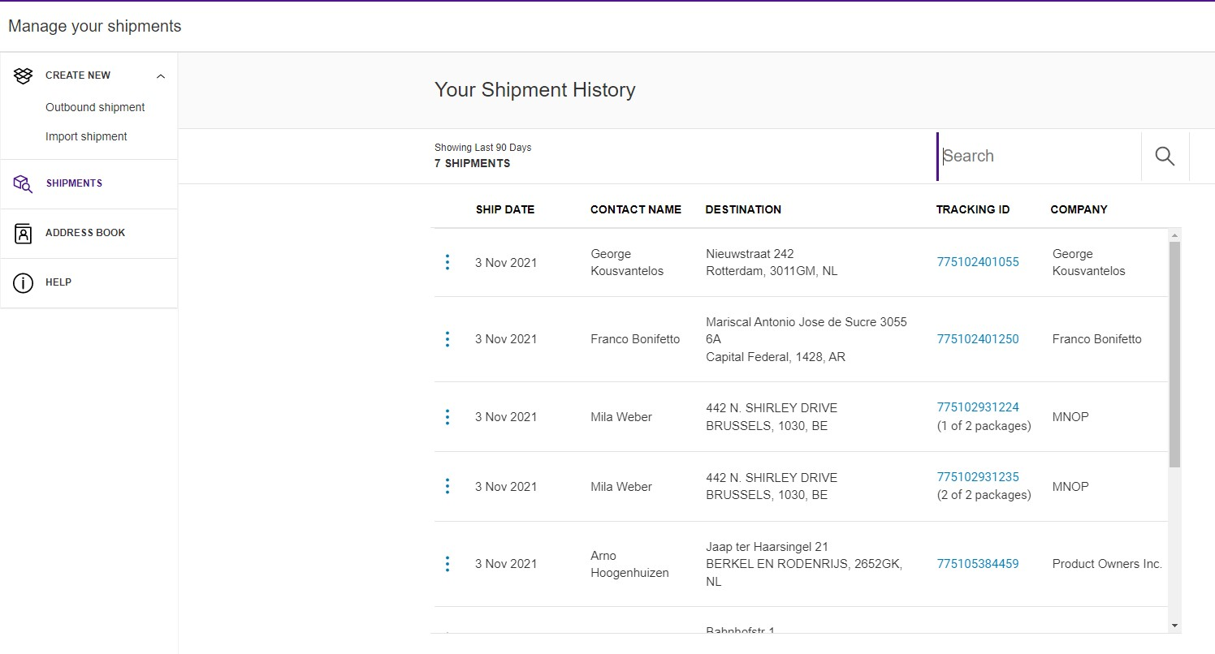To view a list of all your shipments and shipment information, click SHIPMENTS.
You can click individual shipments to check their details and shipping status. It also allows you to repeat the shipment if you need to send it again.
If you click on the Tracking ID number, you can see the current status of the shipment.

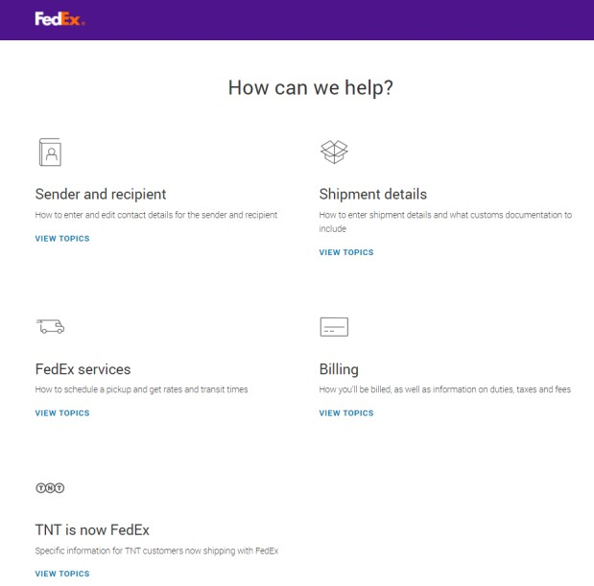
Support Section
There is an extensive “help” section which can be accessed via the application from the left navigation menu.
For an overview, key benefits and the FAQ of the New Ship Manager, please visit the “Shipping Tools” page on xyz.com.
You can always contact your local support via customer service if you have any further questions. The number for your local customer service can be found on your local XYZ.com website.

Left Navigation Menu of Compact View
Compact View was designed for those shippers who would like a clear overview in one page. Everything regarding your shipment is located in one screen.
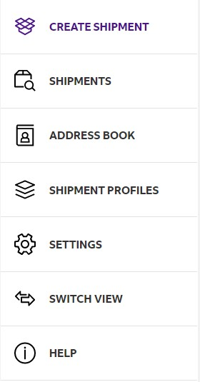
Use this section to create a new shipment. Fill in the address details, package weight and dimensions, select a FedEx service for your shipment, and other required shipment information.
View a list of all the shipments you created. In this section, you can see the shipping status of your shipments and check for any updates. It also allows you to cancel shipments or reprint the labels.
View and edit your FedEx address book.
Create shipment profiles to save information that can be reused when creating new shipments. Select the shipment profile when you create a new shipment and the information will be filled in automatically.
Change the default settings for shipping and printing
Select which FedEx Ship Manager View you want to use. You can switch between the Comfortable View and the Compact View.
Click the Help section to find out more information about FedEx Ship Manager and its features.

Create a new shipment with Compact View
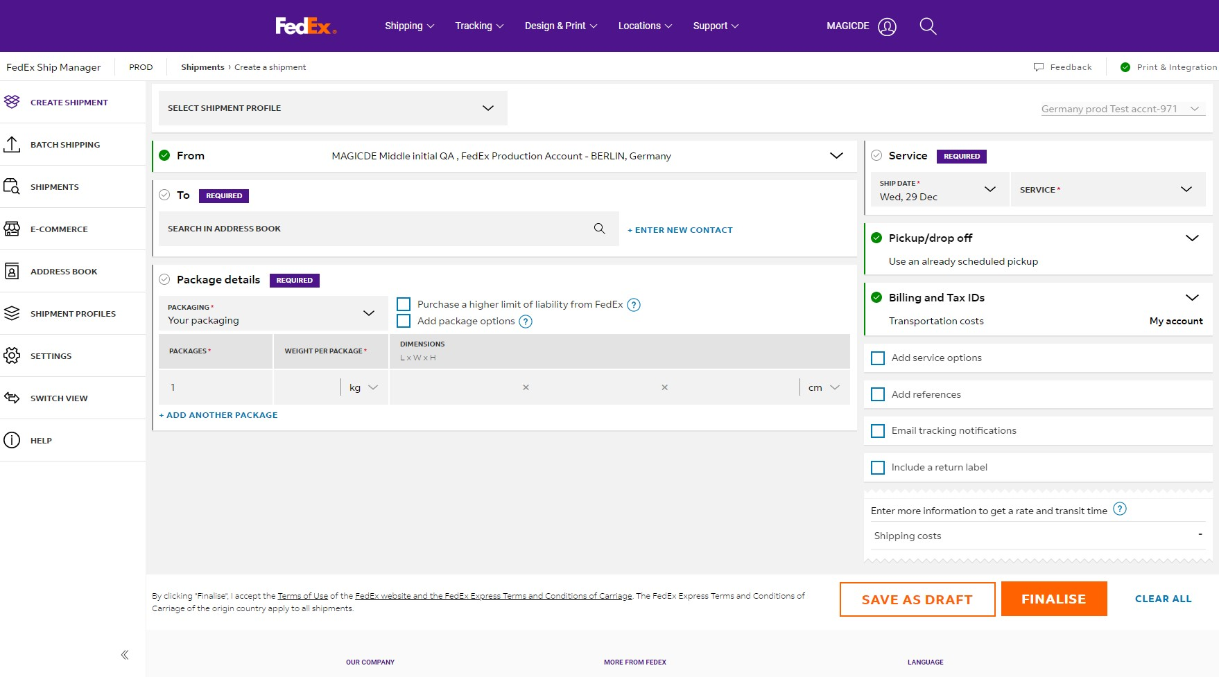
- Click "CREATE SHIPMENT" to open the shipment form.
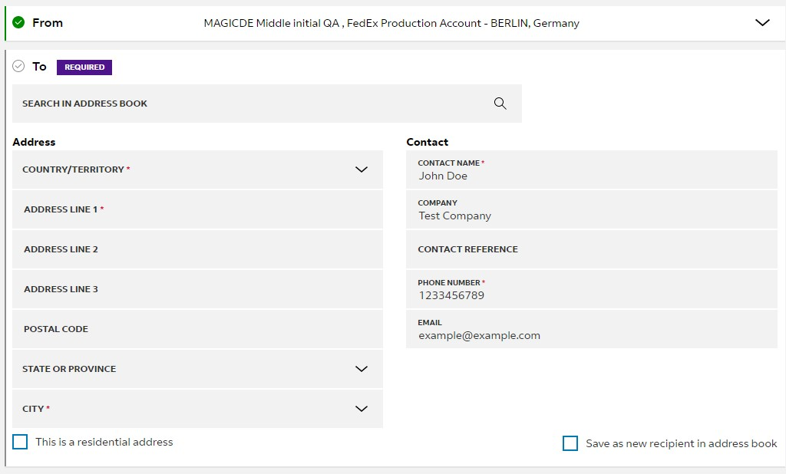
- Provide the address details of the recipient.
You can select the address from your address book or add a new address. To save the new address in your address book, click the checkbox on the right.
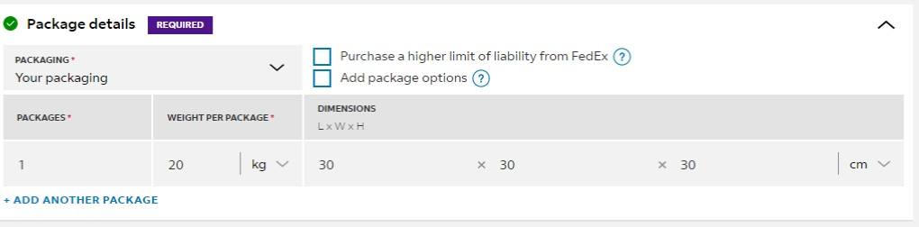
- Provide the package details.
Specify the package weight and dimensions of your shipment. This information is required to calculate the correct cost for your shipment.
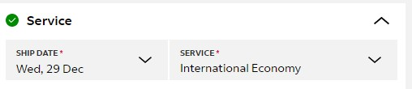
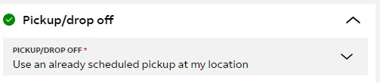
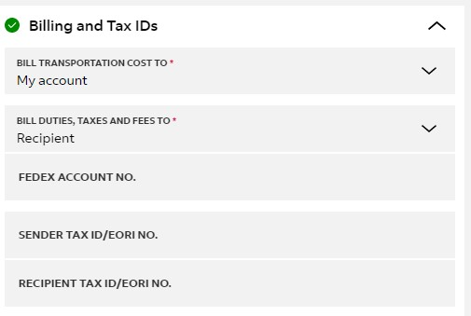
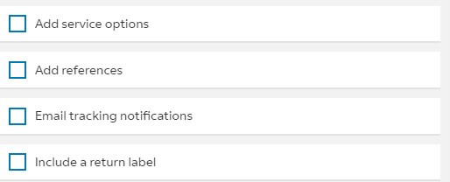
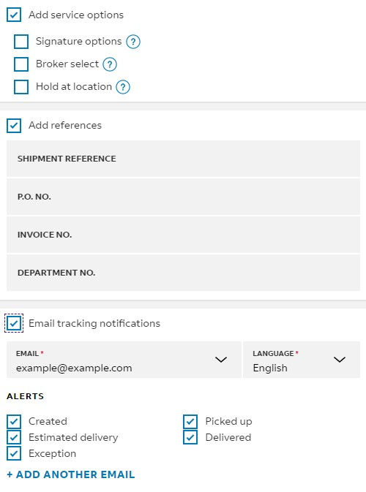
- Select a service for your shipping.Choose a service for shipping. These are adjusted to your FedEx account and may vary between accounts.
- Select the pickup time and date.Here you can select the pickup time and date. You can use an existing pickup, or create a new time and date.
- Specify the billing information.
You can also select who you would like FedEx to bill for duties, taxes and fees (when applicable.) Note that if the requested party does not pay FedEx, we will charge these costs to the shipper.
- Select extra service options.
This section allows for extra options for shipping. If you check any of the boxes, the menu will drop down and show you all available extras.
Signature options allow you to let us know if a shipment needs to be signed for.
If you or the importer want to use your own broker for clearance, you can let us know here.
Rather have the recipient pickup your shipment from a FedEx location? Here you can select this option.
If you have a special reference for your shipment, fill it in here.
Do you want to receive emails with up-to-date tracking information? Check this box and we will let you know what is happening with your shipment. You can also fill in the recipient’s email address to keep them up to date.
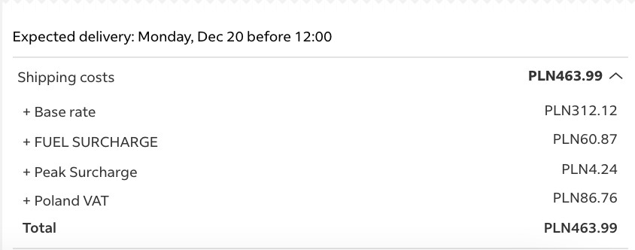
- Shipping rateOnce you filled in all information, a detailed shipping rate will appear.
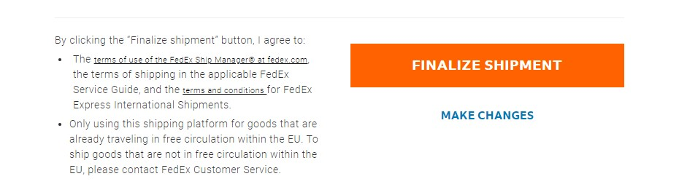
- You can either click SAVE AS DRAFT or click FINALISE and print the label.
Once you are done with filling in all information about your shipment, you can choose to save it as a draft or to finalize it. When you finalize a shipment, the label will be created, and the pickup order will be forwarded to FedEx. You can agree to the terms and conditions and finalize it.

Manage shipments Compact View
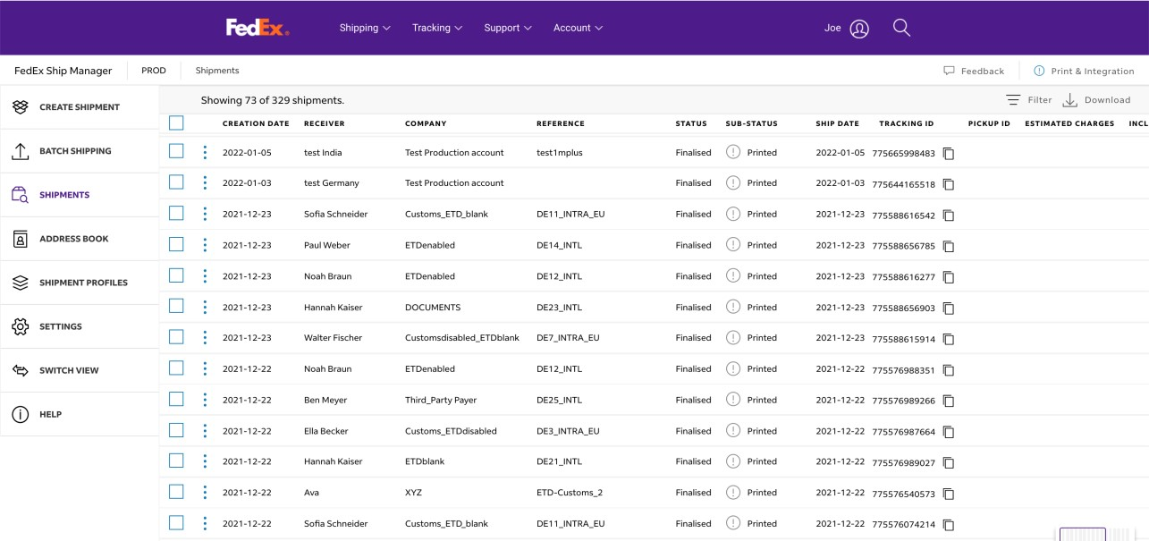
To view a list of all your shipments, the shipping status, and other shipment information, click SHIPMENTS.
You can click individual shipments to check their details and shipping status.
Shipping status definitions:
Draft
- Incomplete; this needs additional information to be completed.
- Expired; this shipment was created too long ago and needs to be recreated.
- Ready to finalize; This shipment is complete, just not finalized yet.
- Failed to finalize; an error occurred during finalizing, please try again.
Finalized
- Not printed; the shipment is complete; the label has not been printed yet.
- Partially printed; part of the label has been printed (can occur with multipiece shipments) - Printed; the label has been printed fully
Shipments that have not been finalized need to be completed in order to come through

Support Section
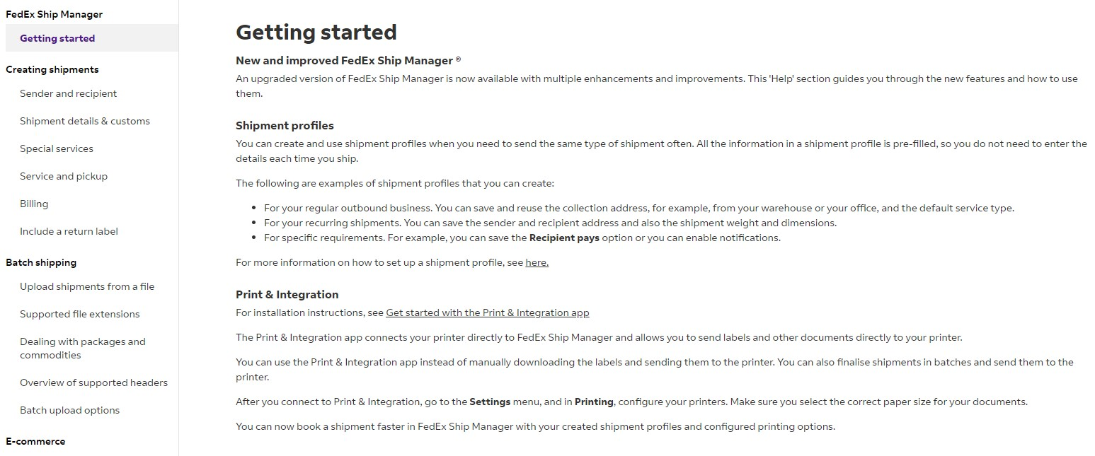
There is an extensive “help” section which can be accessed via the application from the left navigation menu.
For an overview, key benefits and the FAQ of the New FedEx Ship Manager, please visit the “Shipping Tools” page on fedex.com.
You can always contact your local FedEx support via customer service if you have any further questions. The number for your local customer service can be found on your local fedex.com website.

